Mar21 Trading

Monday, March 21, 2016

Machine learning has proven to be a very useful tool for demarcation of normal vs. extreme session. Make sure to take note of the retOPC as a measure for deciding position sizing. The important objective of this week is to come up with a method to figure out whether we are in a normal session or an abnormal session, where normal session is defined by all up or oscillating market.

Some research results from this morning:

Count if retCC<-0.03 & retOPC<0 -> 115

Count if retCC<-0.03 & retOPC>0 -> 32

Focusing on the 32 by weekday and by newBullIndicator:

Mon: 7 (Bull: 1, bear: 6)

Tue : 10 (Bull: 1, bear: 9)

Wed: 3 (bull: 2, bear: 1)

Thu: 8 (bull: 2, bear: 6)

Fri: 4 (bull:2, bear: 2)

As the above graph shows, the order of danger is Tue/Mon+Thu/Fri/Wed.

RetOPC & retCC charting:

|  |  |  |  |  |  |
| --- | --- | --- | --- | --- | --- |
| RetOPC | # of crashes when retOPC< | Cumu | 1-Cumu | Incr. Chg | Safety Lvl |
| 0.02 | 145 | 100% | 0% |  | SAFE |
| 0.019 | 145 | 100% | 0% | 0% | SAFE |
| 0.018 | 145 | 100% | 0% | 0% | SAFE |
| 0.017 | 145 | 100% | 0% | 0% | SAFE |
| 0.016 | 145 | 100% | 0% | 0% | SAFE |
| 0.015 | 145 | 100% | 0% | 0% | SAFE |
| 0.014 | 145 | 100% | 0% | 0% | SAFE |
| 0.013 | 145 | 100% | 0% | 0% | SAFE |
| 0.012 | 145 | 100% | 0% | 0% | SAFE |
| 0.011 | 145 | 100% | 0% | 0% | SAFE |
| 0.01 | 144 | 99% | 1% | 1% | SAFE |
| 0.009 | 144 | 99% | 1% | 0% | SAFE |
| 0.008 | 143 | 99% | 1% | 1% | SAFE |
| 0.007 | 143 | 99% | 1% | 0% | SAFE |
| 0.006 | 143 | 99% | 1% | 0% | SAFE |
| 0.005 | 142 | 98% | 2% | 1% | SAFE |
| 0.004 | 140 | 97% | 3% | 1% | SAFE |
| 0.003 | 139 | 96% | 4% | 1% | SAFE |
| 0.002 | 133 | 92% | 8% | 4% | ok |
| 0.001 | 123 | 85% | 15% | 7% | ok |
| 0 | 115 | 79% | 21% | 6% | ok |
| -0.001 | 104 | 72% | 28% | 8% | ok |
| -0.002 | 100 | 69% | 31% | 3% | Not tradable |
| -0.003 | 89 | 61% | 39% | 8% | Not tradable |
| -0.004 | 83 | 57% | 43% | 4% | Not tradable |
| -0.005 | 75 | 52% | 48% | 6% | Not tradable |
| -0.006 | 68 | 47% | 53% | 5% | Not tradable |
| -0.007 | 62 | 43% | 57% | 4% | Not tradable |
| -0.008 | 58 | 40% | 60% | 3% | Not tradable |
| -0.009 | 50 | 34% | 66% | 6% | Not tradable |
| -0.01 | 48 | 33% | 67% | 1% | Not tradable |
| -0.011 | 43 | 30% | 70% | 3% | Not tradable |
| -0.012 | 40 | 28% | 72% | 2% | Not tradable |
| -0.013 | 37 | 26% | 74% | 2% | Not tradable |
| -0.014 | 34 | 23% | 77% | 2% | Not tradable |
| -0.015 | 30 | 21% | 79% | 3% | Not tradable |
| -0.016 | 27 | 19% | 81% | 2% | Not tradable |
| -0.017 | 26 | 18% | 82% | 1% | Not tradable |
| -0.018 | 24 | 17% | 83% | 1% | Not tradable |
| -0.019 | 23 | 16% | 84% | 1% | Not tradable |
| -0.02 | 21 | 14% | 86% | 1% | Not tradable |
| -0.021 | 19 | 13% | 87% | 1% | Not tradable |
| -0.022 | 16 | 11% | 89% | 2% | Not tradable |
| -0.023 | 16 | 11% | 89% | 0% | Not tradable |
| -0.024 | 14 | 10% | 90% | 1% | Not tradable |
| -0.025 | 14 | 10% | 90% | 0% | Not tradable |
| -0.026 | 14 | 10% | 90% | 0% | Not tradable |
| -0.027 | 14 | 10% | 90% | 0% | Not tradable |
| -0.028 | 14 | 10% | 90% | 0% | Not tradable |

The above table shows the frequency of retCC<-0.03 and the cumulative

Everything opens up decently. It should be a tradable session. The greed is quickly taking over. Cuing @ 9582. I have no chance to enter, which means market sentiment is very greedy. If there are no buying points, sit still. Careful attention must be paid to only buy at day's low or at an attractive discount point.

Markets are currently euphoric, cancelled the bid at the day's low because there is literally no chance for it to happen. Nothing to do today.

Brainstorm a little bit on what has been done so far for 6 months:

LS Trading

Machine learning using R, Python and Spark.

Conditional terminal state estimation using Baysian and recursive tree methods.

Using Java 8 to implement trading models

Trading signals generated by

Tuesday, March 22, 2016

Back from morning running which has resulted in relaxation and mental composure. Daily running routines are to be set up and followed rigorously. Physical exercise used to be carried out regularly last Fall – this is to be resumed in the morning regardless of weather condition. 6:30 to 7:30. Reduce the sources of disturbances in life. Restart reading 道法, plan visiting 名山大川.

Futures trading at a 60 bps premium pre-open. This kind of greed level is unseen, market sentiment remains extremely bullish. Today is Tuesday and it is supposed to be rather weak, looking for a chance to build some position if it opens up and goes lower. The overall sentiment is euphoric.

FTSE index opens down -40bps (assuming the unupdated weights are correct). SHCOMP opens down 60 bps. Building some position around end of morning and end of PM session.

Market takes a plunge but still trading at a 0.34% premium. This is hard to believe. I decide to wait until the market truly panics and premium goes away to enter into a position. There has been too much accumulated unrealized profits. I have missed about 3% of profits and this is not wise to foot the bill for the greed here.

The recent greed demonstrated by A50 futures stands in contrast with the previous situation where it was habitually trading at a discount. Now market has entered a euphoric phase.

Futures go back to 0.1% premium with respect to the cash. The weak opening indicates that today there will be an entrance if you want to.

I was able to enter into 1 lot @ 9712.5. This is the lowest level at the time of purchase. The reason for the buying is that Tuesday usually has a good low-close rebound, as per the experience from the previous 2 weeks.

The chance of a crash is below:

. count if retCC<-0.03 -🡪 147

. count if retCC<-0.03 & weekday == 2 ---🡪 30

. count if retCC<-0.03 & weekday == 2 & amMaxT1>9.75 ---🡪 15

. count if retCC<-0.03 & weekday == 2 & amMaxT1>9.75 & newBullIndicator ----🡪 4

. count if retCC<-0.03 & weekday == 2 & amMaxT1>9.75 & newBullIndicator & retCC[_n-1]>0.02 --🡪 3

. count if retCC<-0.03 & weekday == 2 & amMaxT1>9.75 & newBullIndicator & retCC[_n-1]>0.02 & amMinT1<9.75 --🡪 2

From the above table it can be seen that a catastrophic loss today is quite slim.

3.23

The session was characterized by low volatility.

Outlining the research going forward:

Avoid low>13:30. Set dummy = 1 if dayMinT1>13:30. Use machine learning to train a model.

Study:: the percentile of the open with respect to the max-min range during the previous N days.

Testing other MA (5,10,20,30,60).

Think about the order of importance among all the variables.

Differentiate between fake drop and real drop.

Some preliminary results from the graph:

The goal is to estimate the probability of the daily min occuring after 2pm.

The key is amMaxT at 10:20. If the market breaks high after 10:20, during bull market, there is 20% chance of low appearing after 2pm, during bear market, it depends on the amMin. If amMinT> 11:20, there is more than half chance of the low occuring after 2pm. If amMinT<11:20, there is about 30%.

If the amMax < 10:20, things are more tricky. During bull market, the chance of a 2pm low is 30%. In bear market, it depends on if yesterday was a big drop (defined as < -1.4%). If there was no drop yesterday, 2pm low will occur with at least 50% chance. If there was a big drop, then one needs to look at the amMax. If it is after 9:36, then the chance of 2pm low is 20%. If the min is at the open, one needs to look at if there was a huge loss yesterday (defined as -3.6%). In the case of a huge drop, the chance of 2pm low is 20%, but if there was no huge drop, the probability of a low after 2pm is 60%.

The moral from this analysis is: one can trade most confidently if the amMaxT1>10:20, which is the most significant factor. Second significant factor is whether the market is above the 20DMA. Third factor to consider is the amMinT. If

**Dangerous level for amMinT for every level of amMaxT**

amMaxT1: >10:20. Dangerous if amMinT>11:15.

amMaxT1: <10:20. Dangerous if amMinT>10:40.

Thursday, March 24, 2016

Market finally goes back to trading at a discount, albeit only 20 bps. The extreme bullishness observed last week demonstrated itself in the persistent flat to positive premium, where market participants were highly bullish. As the heat wore off from Tuesday to Thursday, investors are calmer albeit not scared. Being Thursday it is expected to be quite weak but since the morning high occurred around 10:30, the chance of a catastrophic loss is small, it is good to hold until Friday to see what will happen and to benefit from the bullish Friday scenario. Compared with the entrance level of 9710 on Tuesday, this position is already $140 underwater. The relative weakness observed this week is a direct result of the build-up of position of last week, which has made the majority of the market long. Picking up the position on Tuesday at the elevated level was premature in hindsight. It was commendable to have realized that today would be a weak session and liquidated half the position on Wednesday. It is

The experience from last week shows that one had to put on position during expected bullish days, and this needs to be done at the open. During the bullish past Friday and Monday, market did not give way in terms of discount for entrance, you had to enter at fair value. This sometimes is necessary in order to secure a position. Waiting for the entry level to be hit sometimes does not work for bullish days.

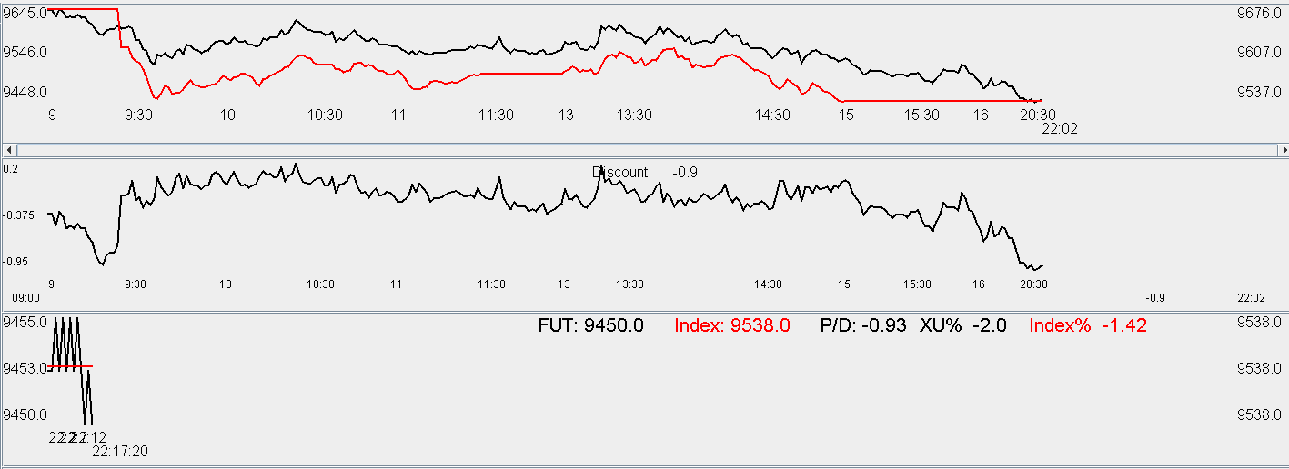

Expectedly weak Thursday. All the premium has been erased and goes into a slight discount. Market panics. Currently all position is underwater. Tomorrow is Friday.

Friday, March 25, 2016

Market opened slightly lower today.

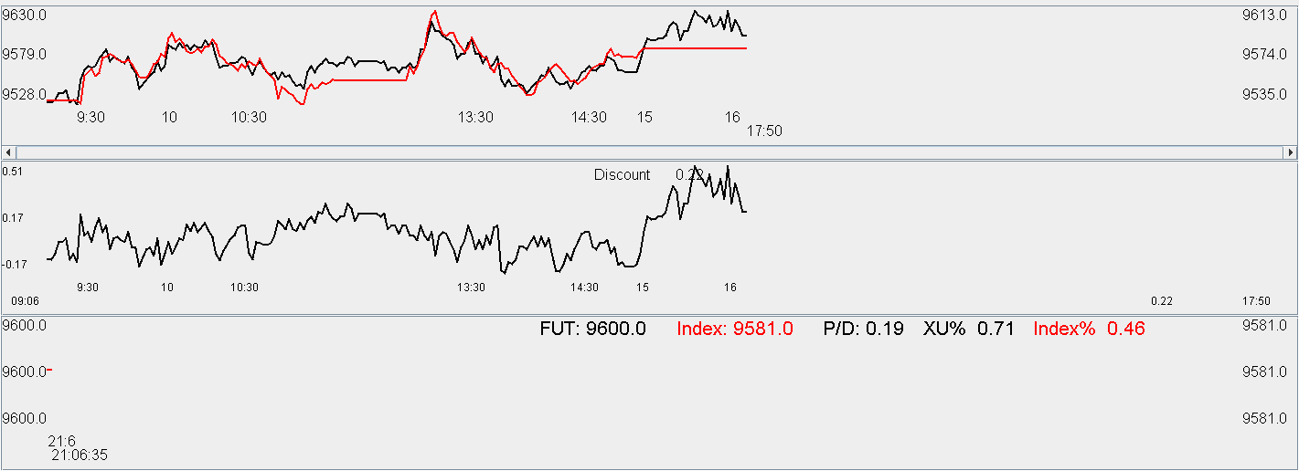

Weekly analysis:

Traded 4 out of the 5 days this week.

Monday morning was characterized by a wave of greedy buying.

Tuesday was characterized by an all-day down day. Wednesday had a greedy rally in the morning which was followed with a tasteless session which was unable to rebound. Thursday afternoon was characterized by a bloodshed.

Friday opened high and closed at the highs.

The first trade on Tuesday was entered at 11am. On this day the premium was very tenaciously positively as investors were still in the greedy mode. The rebound was weaker than expected which indicated the weakness of the session. Further position was built on Wednesday but the rebound was also unsatisfactory, which resulted in the massacre on Thursday.

The improvement this weak included the restart of physical exercise which had been suspended since winter. Physical and psychological well-being was not at its prime form last week. The resumption of physical exercises have served a positive role. Reading of Taoism literature needs to be resumed as these can be relaxing.

Trading-wise, the buying points this week were OK but not great. On Tuesday the buy was a bit early. Upon observing such a weak Tuesday (traditionally the rebound would be strong), on Wednesday morning the position should have been sold, in fact this was the only point one can sell this position this week without losing money. A decent intraday trade was done on Mar 23 but trader was apparently oblivious to the weakness demonstrated by the sapless rebounds that were observed on Tuesday and Wednesday.

Thursday was a catharsis which resulted in investors panic selling into the close. This was a good point to pick up delta as was done. One extra lot of delta could have been picked up in the evening session however there was hesitation regarding this decision because trading was influenced by others.

On the technology front, books have been downloaded which are pending studying. Using python to conduct research on machine learning will be the next step. Market sentiment indicator is to be studied and developed. For example, this Tuesday and Wednesday was apparently characterized by low retCL compared with historical averages. Monday to Wednesday are also three days that daily high occurred in the AM. **Lagged daily high/low AM/PM dummies need to be included in crash prediction**. Essentially, A share index follows a unstable path which are bounded by a set of rules and also affected by overall market positioning. Tuesday and Wednesday was characterized by weak rebounds and Thursday, being traditionally weak, do not have much space to wiggle but to surrender. **Be extra careful of market sentiment and weakness, especially after a big rally**. Market movement on any given day is a mixture of its long run predisposition and the market position. The market position is always neutral in the sense that the long position always equal to the short position. The smart money will be against the majority of the market participants, forming the 20% of the profitable traders, whereas 80% of the market participants provide fodder for the direction to continue at an accelerated pace.

From recent trading history, I have noticed the issue of insufficient buying at crucial panic points. One lot is missing in a lot of the situations. Make sure that this one extra lot is utilized at the panic spots.

One extra thing is that people are stubborn in their ingrained trading practices, and the bad habits formed are often incorrigible. It is hard for people to accept new ideas, methodologies and concepts. People would rather stick with their methodology and fail than to accept something new. Larry's methodology is still on a rudimentary visual inspection level, and it is quite pathetic considering his duration of experience. A high level of technical expertise is required for satisfactorily analyzing the data. To the inexperienced modelers, models are given much more attention than they deserve, and then the entire technical undertaking is discredited and given up due to the disappointment in the rudimentary methodology. It is therefore crucial to gain technical competence to distance oneself aside from inexperienced modelers – the technical methodology needs to be as diversified, well researched and technical as possible (while obeying the rules of Occam's Razor) in order to truly understand the markets.

